Classroom Activity: Using Cognitive Services in Python Scripts

Task: Create a Speech resource in Azure and use it in python script

***Using Speech API***

1. 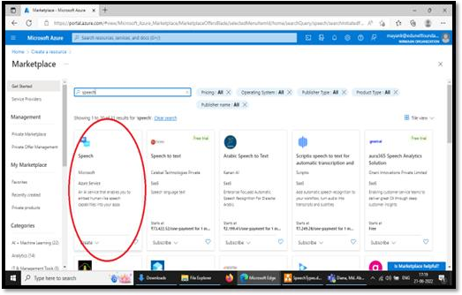Select *Speech* resource from marketplace.
2. Fill in mandatory details, such as
   1. Resource Group
   2. Region
   3. Name
   4. Pricing Tier Click on *Review + Create*

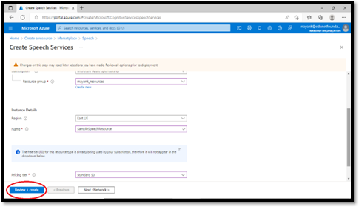

1. Let the validation pass. Click on *Create*.
2. 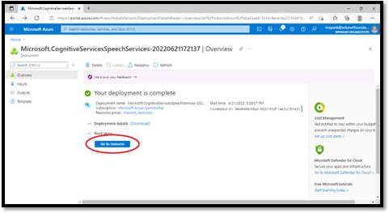Click on *Go to resource*
3. Scroll down. Click on *Keys and Endpoint*. Copy *Key* and *Location/Region*.

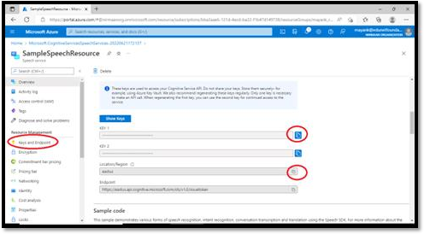

1. Next part is creating an executable code that will take the input, process it and produce the desired output.

For this we will use Visual Studio Code.

Create a file with the provided sample code. Within sample code, use copied Service Key and Service Region

# Sample Code for Text to Speech

import azure.cognitiveservices.speechasspeechsdk speech_config=speechsdk.SpeechConfig(subscription="ServiceKey", region="Service Region") audio_config=speechsdk.audio.AudioOutputConfig(use_default_speaker=True)

# Thelanguageof thevoicethat speaks.

speech_config.speech_synthesis_voice_name='en-US-JennyNeural'

speech_synthesizer =speechsdk.SpeechSynthesizer (speech_config=speech_config, audio_config= audio_config)

# Get text fromtheconsoleand synthesize tothedefault speaker.

print("Enter sometext that youwant tospeak >") text =input()

speech_synthesis_result =speech_synthesizer.speak_text_async(text).get()

if speech_synthesis_result.reason==speechsdk.ResultReason.SynthesizingAudioCompleted: print("Speechsynthesizedfor text [{}]".format(text))

elif speech_synthesis_result.reason==speechsdk.ResultReason.Canceled: cancellation_details=speech_synthesis_result.cancellation_details print("Speechsynthesiscanceled: {}".format(cancellation_details.reason)) if cancellation_details.reason==speechsdk.CancellationReason.Error:

if cancellation_details.error_details:

print("Error details: {}".format(cancellation_details.error_details)) print("Didyou set the speechresourcekey and regionvalues?")

Now, run this file.